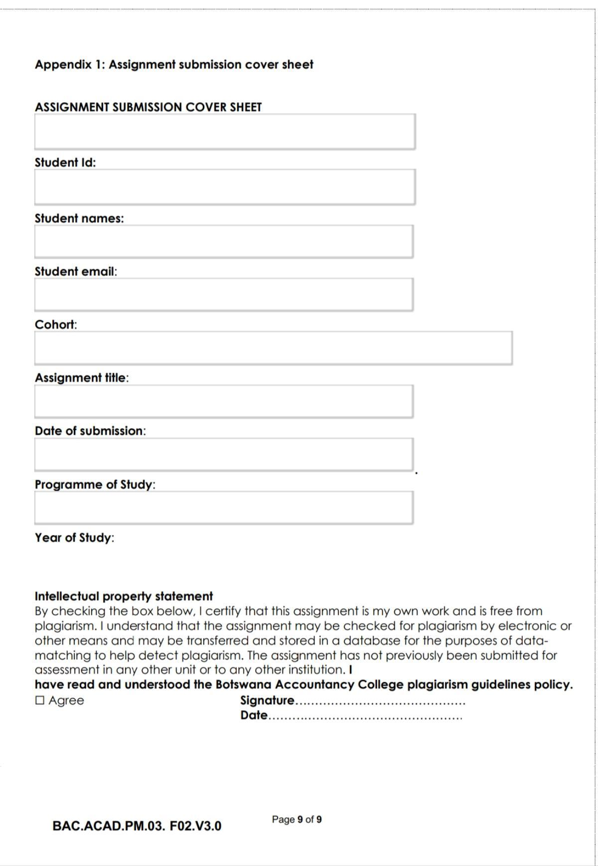
20/05/26
L.Lejage
2025/2026
Computer Systems Engineering
20/05/26
Lana’s Food Hub
Cse1-3
cse25-317@thuto.bac.ac.bw
Oratile Lana Lejage
cse25-317
WMD WEB DESIGN ASSIGNMENT

FOOD BLOG
LANA’S RECIPE HUB
OBJECTIVES
The main objective of Lana’s Recipe Hub is to create an engaging and user-friendly food blog that implements the following:
- To share different or diverse recipes
- To promote cultural exchange
- To build community by allowing readers to engage through comments, reviews and social media
- To provide cooking tips and guidance for beginners
- To inspire people to learn how to cook and to enjoy cooking at the comfort of their homes
TARGET AUDIENCE
- The target audience for the food blog includes different people like young teens, students, adults and families who are interested in cooking simple and affordable meals or just dining in a nearby restaurant to get the flavour of different dishes.
- It is also suitable for individuals who enjoy exploring new recipes, as well as those interested in local Botswana cuisines.
TAXONOMY
Lana’s Recipe Hub is organised into seven clearly defined sections, each accessible from the persistent navigation bar at the top of every page. This structure ensures intuitive browsing and logical content grouping across the entire site.

Home
The main entry point. Contains a full-width featured banner section with a headline and call-to-action buttons. Below it, a category-pill filter row lets users browse by cuisine type. A mosaic image grid showcases popular recipes, followed by a statistics strip (recipes, cuisines, users), a newsletter signup form, and the site footer.

Recipes
A dedicated recipe listing page. Displays a full-width hero image with the page title overlaid. Below, recipes are grouped by cuisine — Italian, Indian, Mexican, Thai, Japanese, and French — each shown in a styled detail card containing the dish name, prep/cook time, servings, a full ingredient list, and numbered instructions.

Cuisines
Groups recipes by cultural origin. Displays a page banner at the top, then a responsive three-column card grid. Each cuisine card shows a thumbnail image, the cuisine name, a recipe count, and a “View Recipes” button linking to the recipes page.

Tips
A practical cooking guidance section. Displays a banner image followed by a five-column tips grid on the desktop view. Each tip card has an icon, a bold title (e.g. Food Safety, Personal Hygiene, Utensil Safety, Preparation, Cleanliness), and a short descriptive paragraph.

About
Tells the story of Lana’s Recipe Hub. Features a page banner, a two-column story grid (photo + founding narrative), a Mission & Vision two-card section, a three-card Meet the Team grid (avatar, name, role, bio), and a community call-to-action panel with Sign Up and Contact Us buttons.

Contact
Provides three equal-width contact info cards (Email Us, Call Us, Social Handles — TikTok, Instagram, Facebook). Below them, a two-column layout places a validated HTML5 message form on the left and a collapsible FAQ accordion on the right, with a “View All FAQs” link at the bottom.

Navigation follows the three-click rule — any piece of content is reachable within three interactions from the homepage. All six pages are interlinked via the persistent top navigation bar, and internal links within pages (e.g. “View Recipes” buttons on the Cuisines page) connect related content.

LAYOUT PLAN
The layout of Lana’s Recipe Hub follows a consistent single-column container structure across all pages, with a maximum width of 900px centred on a warm cream background (#FFF8F0). Every page shares the same header and navigation, and ends with the same footer, ensuring visual coherence throughout the site.
- The HEADER sits at the top of every page and contains the site logo (“Lana’s Recipe Hub” in bold brown), a full-width search bar with placeholder text that adapts per page (e.g. “Search recipes, cuisines...”), and a search button styled in amber (#C8923A). On the Recipe page, the header also displays social-link icon placeholders to the right of the search bar.

- The NAVIGATION BAR is a full-width dark-brown (#6B3A1F) horizontal strip directly beneath the header. It contains seven links: Home, Recipes, Cuisines, Tips, About, and Contact, rendered in a warm cream colour. The currently active page link is highlighted with a bold style and an amber underline (#C8923A) to provide clear wayfinding. On the About and Contact pages the navigation appears without a page-body wrapper, matching a simpler layout.

- The FEATURED CAROUSEL appears on the Home page only and is built using the Bootstrap 5 carousel component. It cycles through three image slides with Previous and Next arrow controls and dot indicators. Each slide spans the full container width and is intended to showcase seasonal recipes or editorial highlights.

- The RECIPE CARD GRID is used on both the Home page (Popular Recipes) and the Cuisines page (View Recipes). Cards are arranged in a three-column responsive grid with 12–14px gaps. Each card has a rounded border, a top image area, and a body with the recipe name (bold, dark brown) and a meta line showing prep time and difficulty (e.g. “30 min · Easy”). Cards have a hover state that deepens the border colour to amber.

- The RECIPE DETAIL LAYOUT is specific to individual recipe pages. It begins with the recipe title, followed by a wide banner image placeholder (16:7 aspect ratio). Below the image, a horizontal meta row shows star rating, review count, cook time, and difficulty, separated by pipe characters. A two-column grid then presents Ingredients on the left and Instructions on the right, each in a bordered panel. At the bottom, an interactive star-rating widget and a comment input bar with a “Post Comment” button are provided.
- The ABOUT PAGE LAYOUT features a horizontally divided story box containing an image placeholder, the founding narrative text, and side-by-side Mission and Vision columns separated by vertical rule dividers. Below the story box, a decorated “MEET THE TEAM” section header introduces a three-column team card grid. Each team card holds an avatar icon, name, role, short bio, and a “View Full Team” button. The page ends with a centred community call-to-action box.

- The CONTACT PAGE LAYOUT presents three equal-width contact cards (Email, Phone, Social Handles) in a top row. The social card lists TikTok, Facebook, and Instagram handles in styled bordered rows with platform icons. Below this, a two-column grid positions the message form on the left and the FAQ accordion on the right. All input fields use the site’s cream background (#FFF8F0) with amber focus borders.

- The FOOTER is shared across all pages and uses a deep-brown background (#3E2010) with cream-coloured links. It contains three anchor links: Newsletter Signup, Contact Info, Social Links, and a copyright notice (“© Lana’s Recipe Hub”). The footer sits flush at the bottom of the site container with rounded bottom corners matching the outer border.

- The TIPS PAGE LAYOUT uses a compact, fixed-height single-screen design with no vertical scrolling. The page title “Cooking Tips & Tricks” appears left-aligned at the top of the page body. Below it, a five-column grid displays five tip categories side by side: Food Safety, Personal Hygiene, Utensil Safety, Preparation, and Cleanliness. Each column has a bold section heading underlined by an amber rule, followed by four tip items, each with a bold title and a short descriptive sentence. The compact design ensures all tips are visible without scrolling on a standard desktop viewport.

Technical Brief
- The site is built with HTML5 for all page structure and CSS3 for styling and layout. Each page has its own page-specific stylesheet (e.g. home-style.css, recipe-style.css, tips-style.css) that imports a shared base file (main-style.css) containing the site’s colour palette, typography, topbar, navigation bar, footer, and reusable component styles such as buttons, avatar, placeholder lines, and section headers.
- The Bootstrap 5 framework is used on the Home page to power the featured carousel component. Bootstrap’s JavaScript bundle is also included on that page to enable the carousel’s slide controls. All other pages rely solely on custom CSS without Bootstrap dependencies, keeping page weight low.
- The site’s colour system uses a warm, food-inspired palette defined in main-style.css: deep brown #3E2010 and #6B3A1F for headings and navigation, amber #C8923A for interactive accents and active states, warm cream #FFF8F0 and #F0E2C4 for backgrounds and image placeholders, and soft gold #DEC99A for borders and dividers. Arial is used as the universal typefont.
- Layout is achieved entirely with CSS Grid and Flexbox. The topbar and navigation use Flexbox for horizontal alignment. Page-level content areas such as the recipe card grid (3-column), the cuisine card grid (3-column), the review card grid (3-column), the team member grid (3-column), and the tips section grid (5-column) all use CSS Grid with defined column widths and gap spacing. Two-column splits on the Contact and Recipe pages also use CSS Grid.
- Development tooling includes Visual Studio Code for code editing, Figma and Canva for wireframe design and graphic assets, and GitHub Pages for hosting. The project is version-controlled with Git, with files committed and pushed to a GitHub repository

Quality Assurance
- To make sure the website works correctly and provides a good user experience, different tests will be carried out. The website was tested on popular browsers such as Google Chrome, Mozilla Firefox, and Microsoft Edge to ensure it displays properly on each one.
- It was also be tested on different devices, including mobile phones, tablets, and desktop computers, to make sure it is responsive and easy to use.Although, in mobile phones and tabs, it is not responsive. In addition, all features such as links, forms, and interactive elements will be checked to confirm they are working correctly.

Publishing and Promotion
- Lana’s Recipe Hub will be published using GitHub Pages, which will allow the website to be hosted from a GitHub repository. The process will include creating a repository, uploading the website files, and enabling GitHub Pages. Git commands will be used to add files, save changes, and upload them to the repository.
- After publishing, the website will be available through a link. To promote the website, different methods will be used, such as sharing it on social media, improving its visibility on search engines, and encouraging users to interact with and share content on the platform.
Future Developments and Recommendations
- Even though Lana’s Recipe Hub will be functional, there will still be ways to improve it in the future. One improvement will be adding user accounts so users can save their favorite recipes and create their own collections. Better search and filtering options will also be added to help users find content more easily.
- The website will also include video tutorials and possibly live cooking sessions to make it more engaging. E-commerce features may be added in the future to allow the sale of cooking tools or ingredients. Lastly, a mobile app version of the website will be developed to make it more convenient for users to access the platform.

WIREFRAMES

HOME PAGE WIREFRAME
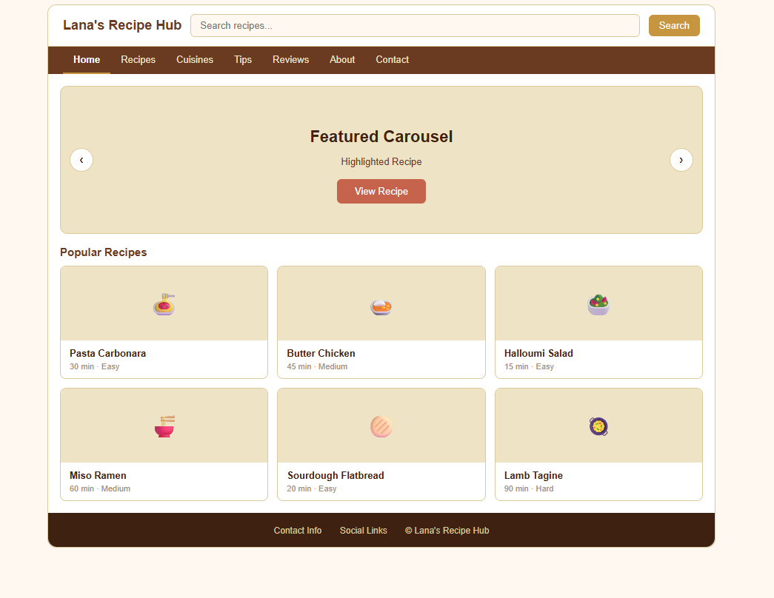

RECIPE WIREFRAME
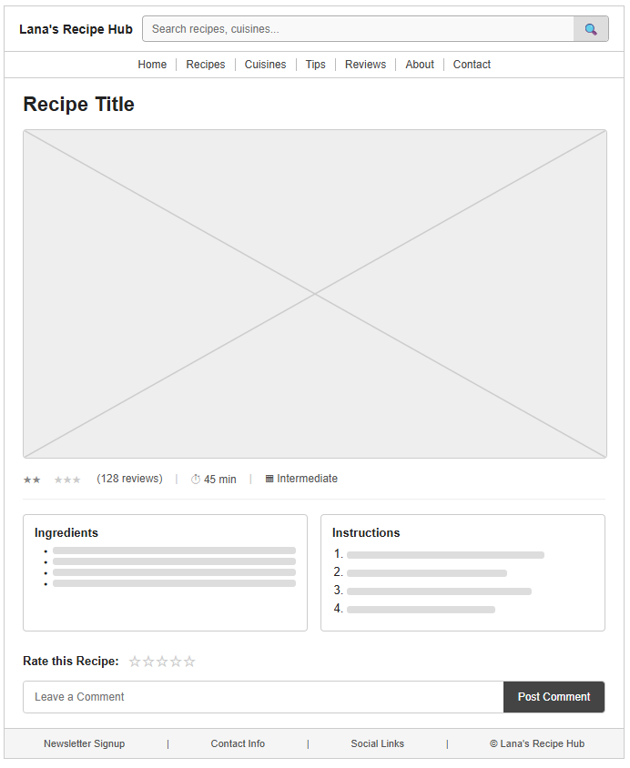
CUISINE WIREFRAME
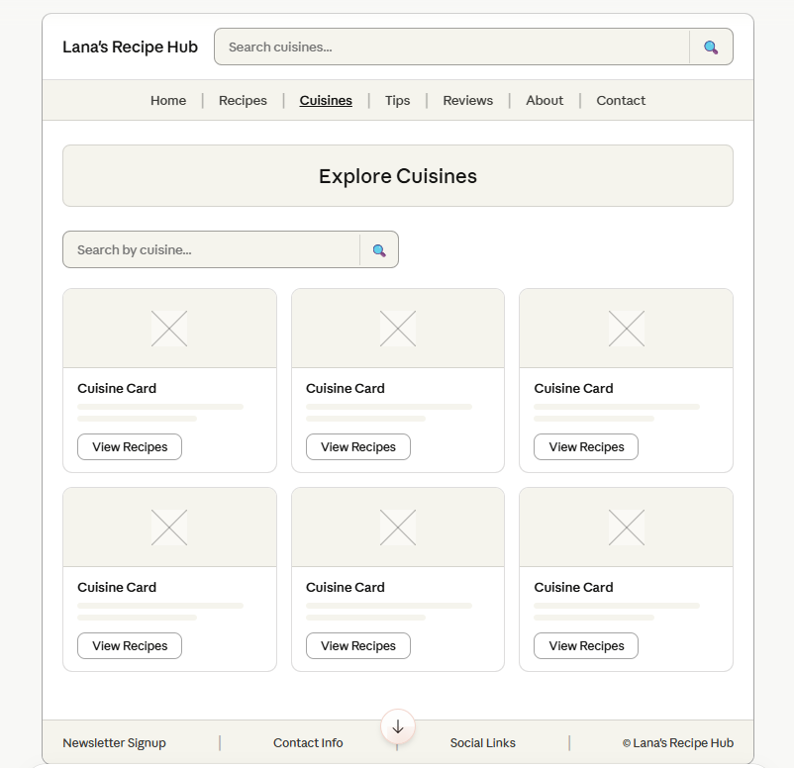
TIPS WIREFRAME
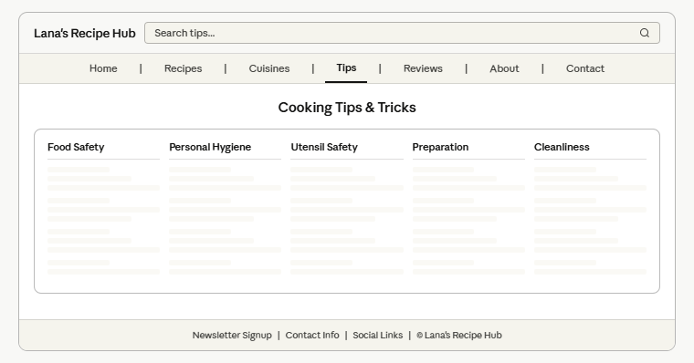

ABOUT US WIREFRAME
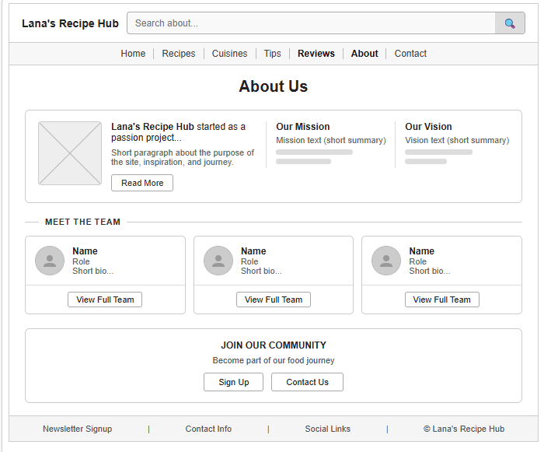

CONTACT US WIREFRAME
